**Institute of Technology Tralee**

**BSc. in Computing with Specialism (Group 3) - Year 1**

**Continuous Assessment #1**

**Date: 23/10/13**

**Time: 10a.m. – 12p.m.**

**Introduction to Programming**

**Instructions:** Attempt the following question. You should use the JCreator IDE for coding. When you are finished you must print out your code for correction.

**________________________________________________________**

**Q1.**

The figure below shows an electrical circuit consisting of a battery and 2 resistors in parallel with each other. The voltage of the battery is V Volts and the resistances of the resistors are R1 Ohms and R2 Ohms respectively.

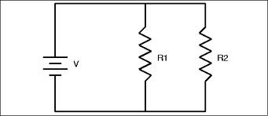

It is possible to calculate the total electrical current, I, that flows through the circuit by using the formula:

Write a Java program that reads in the values of the battery voltage, V, along with the 2 resistance values R1 and R2 and uses the formula above to determine the total current I that flows through the circuit. Note that the resistances will both be **whole numbers** here.

Once the total current is determined it should then be displayed correct to **the nearest whole number**.

Your program should contain a little **fool-proofing code** also to ensure that only positive voltage values are accepted by the program. Should a zero or negative voltage value be entered then an appropriate error message should be displayed and the program should then immediately terminate, without requesting any further information or performing any other calculations.

Using the test values as indicated in the screen shots below, the program should give you **exactly** the following output when it runs, including banners, blank lines, units etc.

Also note that there will be a few marks awarded for the use of **meaningful variable names**, having a  **single and multi-line comment at the top of the program** and for **proper indentation** in the coding of the program.

**Sample Screen Shots**

**The user enters an invalid voltage value here**

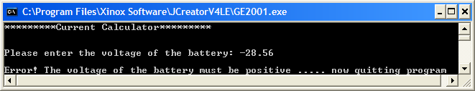

**The user enters a valid voltage value here**

